Shrinkage correlation: USDCHF and EURGBP
Method 08 / eight-major panel / delta = 0.2 and Ledoit-Wolf / Alpari D1 full available history

Study setup
Logical pair: USDCHF , EURGBP
Broker symbols: USDCHF_i , EURGBP_i
Snapshot: 2026-11-03_majors_alpari_D1
Timeframe: D1
Common eight-major panel window: 1999-01-06 to 2026-11-02 (UTC bar dates)
Panel matched return count n: 7127
Dropped unfinished last bar dated 2026-11-03 UTC after a tick-volume check against the prior complete day.
Fixed shrinkage: delta=0.2, mu=3.9170889e-05 (mean of diag(S))
Ledoit-Wolf estimated delta: 0.0042157642
Panel symbols: EURUSD, GBPUSD, AUDUSD, NZDUSD, USDJPY, USDCHF, USDCAD, EURGBP
Complete matched rows (Excel): USDCHF-EURGBP_Shrinkage_D1.xlsx
Complete matched rows (HTML table): USDCHF-EURGBP_Shrinkage_D1_data.html

Method carried forward
Shrinkage blends the sample covariance matrix S of matched daily log returns of close, ln(close_t / close_t-1), toward a simple target, then converts the shrunk covariance into correlations. Quotes are not inverted. This experiment builds one common calendar across all eight majors, forms S with the unbiased n-1 divisor, then reports two shrinkage specs: fixed delta = 0.2 with mu equal to the average sample variance (mu * I target), and sklearn Ledoit-Wolf with its estimated delta. Pair reports pull rho_ij from those panel matrices. Same-panel Pearson r is a side check only. Shrinkage improves conditioning; it is not a cause, not a lead, and not a trading signal.

Results
pearson_r | rho_02 | rho_LW | rho_02_minus_r | rho_LW_minus_r | delta_LW
-0.325016 | -0.247055 | -0.323271 | 0.077961 | 0.001745 | 0.00421576

Conclusion
Over the common 7127-day eight-major panel for USDCHF and EURGBP (broker quote directions unchanged), fixed-delta shrinkage correlation at delta=0.2 is -0.2471 (negative, weak linear link in this sample). Ledoit-Wolf rho is -0.3233 with estimated delta=0.004216. Same-panel Pearson r is -0.3250 (rho_02 minus r = 0.0780; rho_LW minus r = 0.0017). This does not establish cause, lead-lag, or a lasting trading rule.

Charts
Daily closes
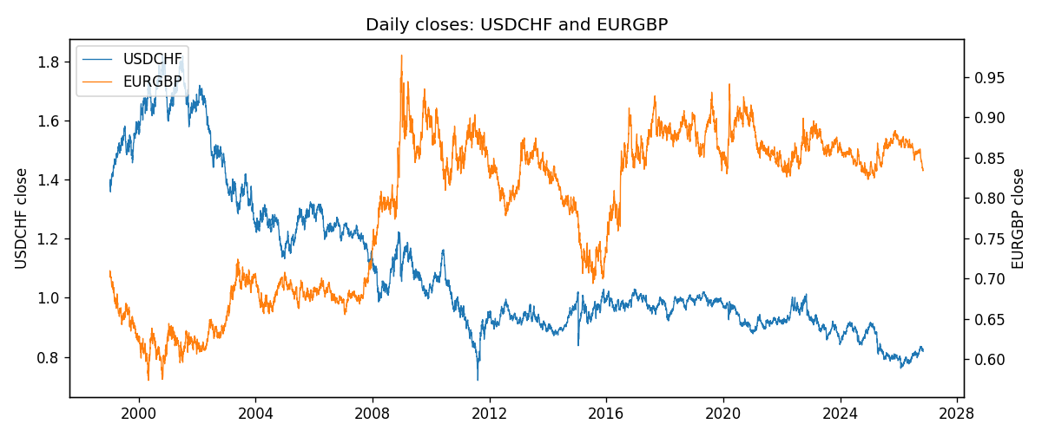
Daily log returns
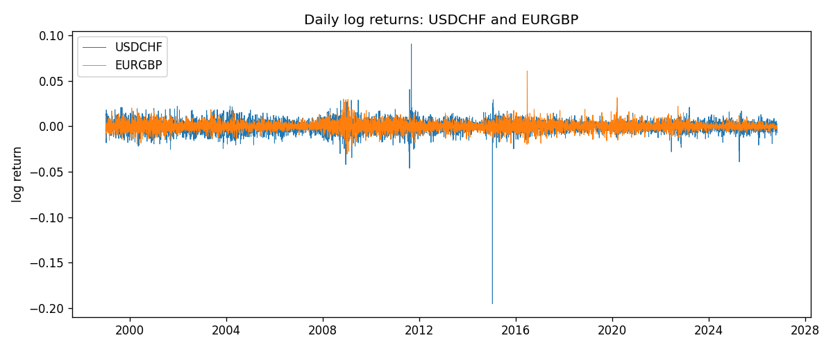
Log-return scatter
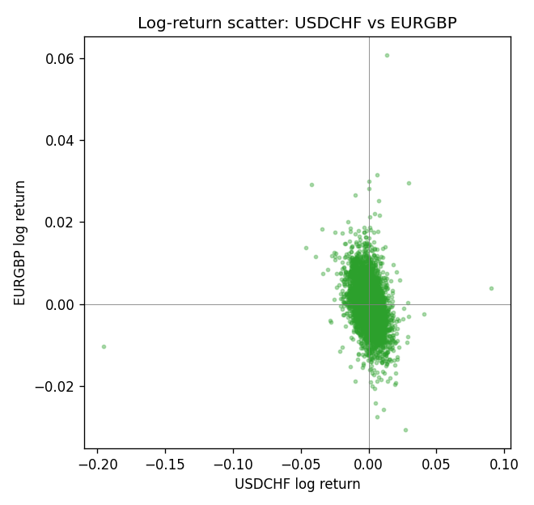

Data report
Every panel row for this pair slice is stored in the sibling Excel workbook named USDCHF-EURGBP_Shrinkage_D1.xlsx. Full-panel covariance and correlation matrices are saved once under outputs/ as CSV files. Embedding all rows as a Word table is impractical at this length; the Word file holds the column list, column summaries, and the first and last 15 matched rows.
Columns: time, USDCHF_open, USDCHF_high, USDCHF_low, USDCHF_close, USDCHF_tick_volume, USDCHF_spread, USDCHF_real_volume, USDCHF_log_return, EURGBP_open, EURGBP_high, EURGBP_low, EURGBP_close, EURGBP_tick_volume, EURGBP_spread, EURGBP_real_volume, EURGBP_log_return
Column summaries (panel rows)
column | count | mean | std | min | 25% | 50% | 75% | max
USDCHF_open | 7127 | 1.0950724 | 0.25120393 | 0.72022 | 0.92018 | 0.98921 | 1.23375 | 1.8219
USDCHF_high | 7127 | 1.1003422 | 0.25292835 | 0.73305 | 0.924355 | 0.99265 | 1.2388 | 1.8313
USDCHF_low | 7127 | 1.0899719 | 0.24962782 | 0.08565 | 0.91675 | 0.98562 | 1.22815 | 1.8121
USDCHF_close | 7127 | 1.0950652 | 0.25109829 | 0.72025 | 0.92039 | 0.98915 | 1.23375 | 1.8217
USDCHF_tick_volume | 7127 | 74858.54 | 113805.19 | 350 | 12933.5 | 40528 | 70784 | 858589
USDCHF_spread | 7127 | 25.804827 | 24.609722 | 0 | 5 | 16 | 50 | 100
USDCHF_real_volume | 7127 | 2.3477824e+10 | 8.9470976e+10 | 0 | 0 | 0 | 0 | 1.9331921e+12
USDCHF_log_return | 7127 | -7.023e-05 | 0.006591 | -0.19545699 | -0.00334576 | 8.055e-05 | 0.00331687 | 0.09051364
EURGBP_open | 7127 | 0.78791082 | 0.09637243 | 0.5734 | 0.6884 | 0.83449 | 0.8655 | 0.9769
EURGBP_high | 7127 | 0.79099288 | 0.09674788 | 0.5789 | 0.6906 | 0.83742 | 0.868415 | 0.9799
EURGBP_low | 7127 | 0.78520819 | 0.09619038 | 0.5682 | 0.6864 | 0.83222 | 0.86303 | 0.9661
EURGBP_close | 7127 | 0.7879552 | 0.09637142 | 0.5735 | 0.6884 | 0.83458 | 0.86556 | 0.977
EURGBP_tick_volume | 7127 | 87771.585 | 145890.89 | 332 | 6734 | 44866 | 82002 | 1424684
EURGBP_spread | 7127 | 21.129928 | 19.050945 | 0 | 4 | 13 | 40 | 50
EURGBP_real_volume | 7127 | 2.8086114e+10 | 1.3572254e+11 | 0 | 0 | 0 | 0 | 3.5726265e+12
EURGBP_log_return | 7127 | 2.379e-05 | 0.00487339 | -0.03067367 | -0.00262314 | -9.978e-05 | 0.00256668 | 0.06075387
First 15 panel rows (selected columns)
time | USDCHF_close | EURGBP_close | USDCHF_log_return | EURGBP_log_return
1999-01-06 | 1.3912 | 0.7019 | 0.013605652 | -0.013303338
1999-01-07 | 1.3782 | 0.7097 | -0.0093883841 | 0.011051402
1999-01-08 | 1.3935 | 0.7062 | 0.011040268 | -0.004943862
1999-01-11 | 1.4009 | 0.7053 | 0.0052963193 | -0.0012752393
1999-01-12 | 1.3872 | 0.7077 | -0.0098275602 | 0.0033970309
1999-01-13 | 1.3621 | 0.708 | -0.018259701 | 0.00042381861
1999-01-14 | 1.3588 | 0.7066 | -0.0024256692 | -0.0019793588
1999-01-15 | 1.3834 | 0.7012 | 0.01794228 | -0.0076715819
1999-01-18 | 1.379 | 0.7017 | -0.0031856384 | 0.00071280921
1999-01-19 | 1.3789 | 0.7007 | -7.2518946e-05 | -0.0014261269
1999-01-20 | 1.3889 | 0.7021 | 0.0072259871 | 0.0019960086
1999-01-21 | 1.3836 | 0.7016 | -0.0038232689 | -0.00071240297
1999-01-22 | 1.3834 | 0.7004 | -0.0001445609 | -0.0017118406
1999-01-25 | 1.3868 | 0.6966 | 0.0024546976 | -0.0054402425
1999-01-26 | 1.3897 | 0.6962 | 0.0020889617 | -0.00057438255
Last 15 panel rows (selected columns)
time | USDCHF_close | EURGBP_close | USDCHF_log_return | EURGBP_log_return
2026-10-13 | 0.83244 | 0.84458 | -0.0024955621 | 0.00020130374
2026-10-14 | 0.83489 | 0.84553 | 0.0029388325 | 0.0011241873
2026-10-15 | 0.82676 | 0.84479 | -0.0097855323 | -0.00087557391
2026-10-16 | 0.82377 | 0.84307 | -0.0036230826 | -0.0020380844
2026-10-19 | 0.82677 | 0.84259 | 0.0036351779 | -0.00056950988
2026-10-20 | 0.8246 | 0.83957 | -0.0026281224 | -0.0035906254
2026-10-21 | 0.82427 | 0.83839 | -0.00040027413 | -0.00140647
2026-10-22 | 0.82032 | 0.83682 | -0.0048036381 | -0.0018743924
2026-10-23 | 0.82497 | 0.83751 | 0.005652514 | 0.00082421033
2026-10-26 | 0.82649 | 0.83762 | 0.0018407959 | 0.00013133309
2026-10-27 | 0.82865 | 0.83595 | 0.0026100526 | -0.0019957343
2026-10-28 | 0.82781 | 0.83651 | -0.0010142111 | 0.00066967224
2026-10-29 | 0.82379 | 0.83553 | -0.0048680164 | -0.0011722209
2026-10-30 | 0.82438 | 0.83351 | 0.00071594559 | -0.0024205543
2026-11-02 | 0.81851 | 0.83426 | -0.0071459744 | 0.00089940465

